Scaling

Definition
# Source: AI Source: Provided by: [Data Path: Persons Table -> ID Column: 1, Name_En Column: Motasem Essam] -> From: [ChatGPT] on [7/25/2026]
Scaling is a geometric transformation that changes the size of a figure by multiplying its dimensions by a common scale factor, while preserving its overall shape.
Scaling changes distances from a reference point by the same factor. Unlike an isometry, scaling generally does not preserve the original size.
For a scale factor $k>0$:
$$\boxed{L^{'}=kL}$$
where:
- $L$= original length
- $L^{'}$= scaled length
- $k$= scale factor
Scaling is a fundamental form of a similarity transformation.

Fundamental Concept
# Source: AI Source: Provided by: [Data Path: Persons Table -> ID Column: 1, Name_En Column: Motasem Essam] -> From: [ChatGPT] on [7/25/2026]
When a figure is scaled:
- Every corresponding length is multiplied by the same scale factor.
- Corresponding angles remain equal.
- The shape is preserved.
- The size may increase, decrease, or remain unchanged.
For two points $P$and $Q$:
$$\boxed{d\left(P^{'} , Q^{'}\right)=k d\left(P , Q\right)}$$
Thus, scaling preserves proportions rather than absolute lengths.
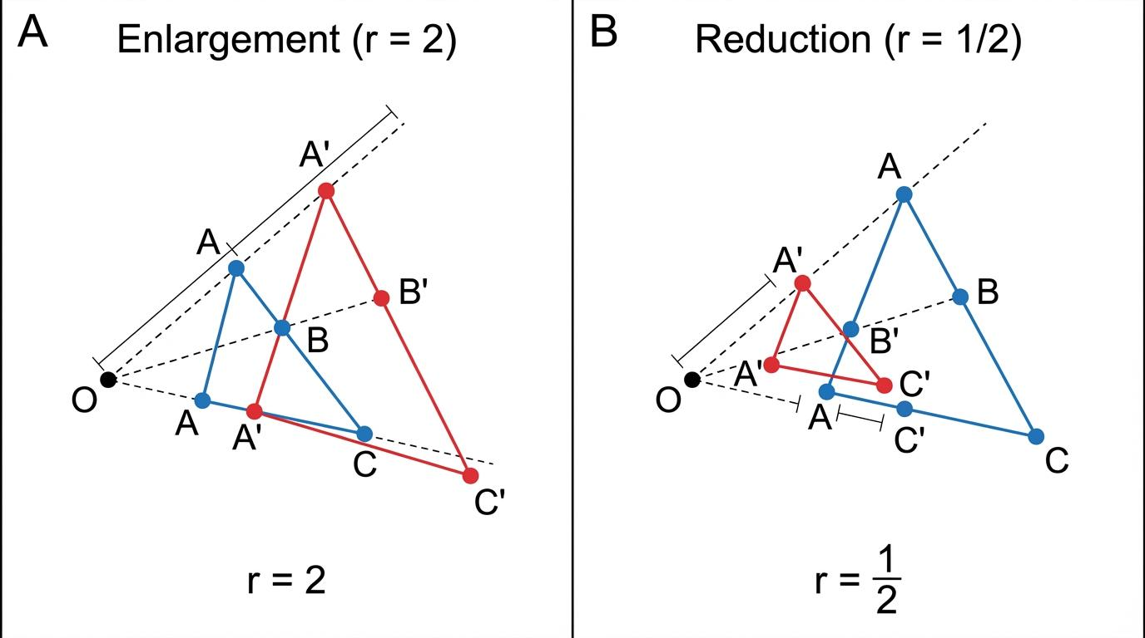
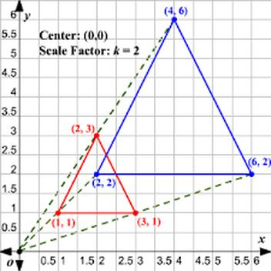
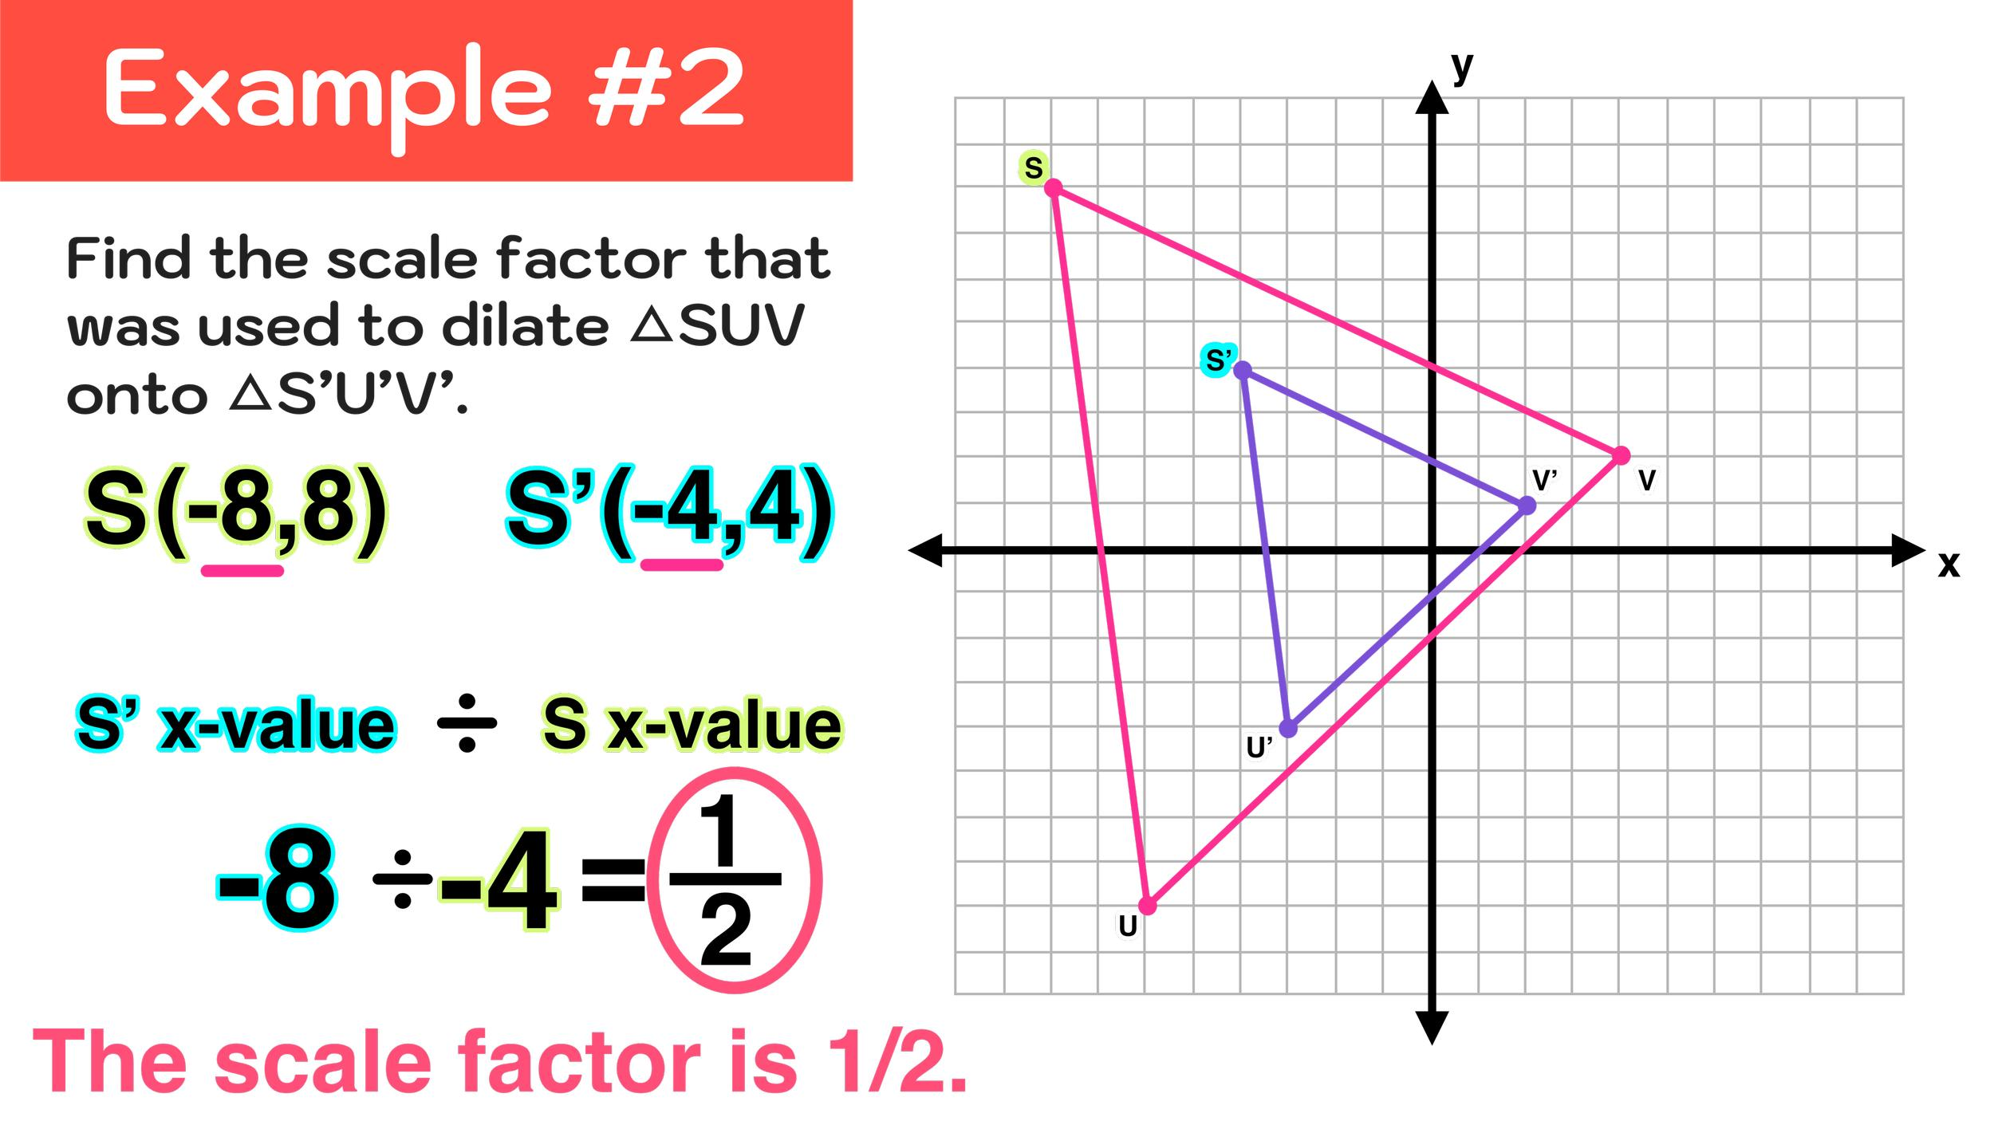
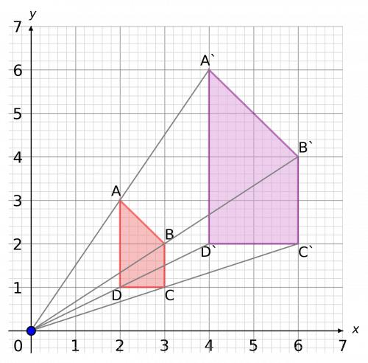
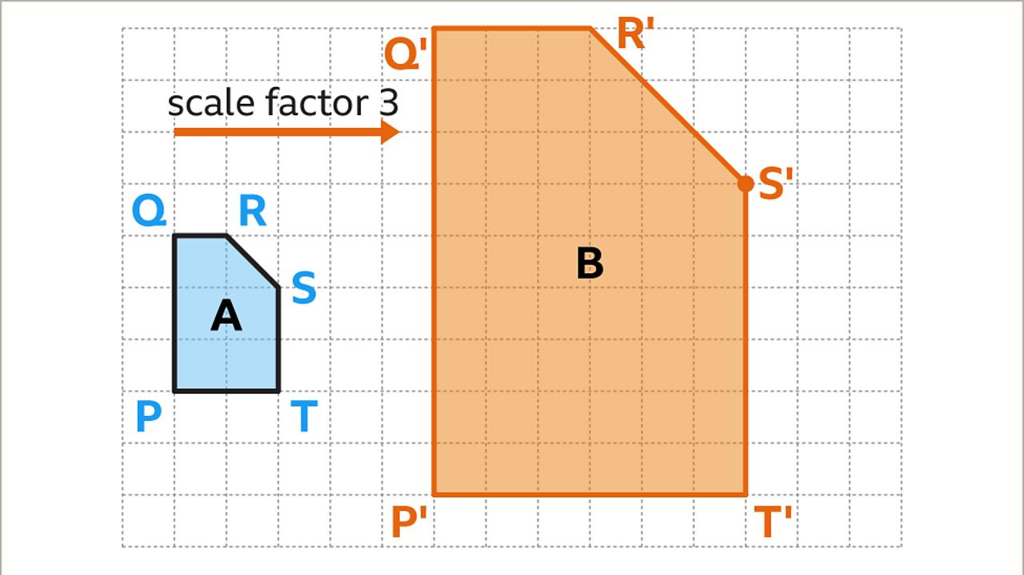
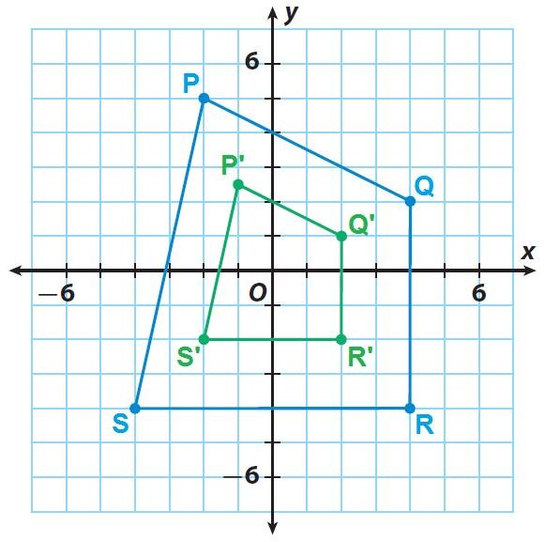

Main Characteristics
# Source: AI Source: Provided by: [Data Path: Persons Table -> ID Column: 1, Name_En Column: Motasem Essam] -> From: [ChatGPT] on [7/25/2026]
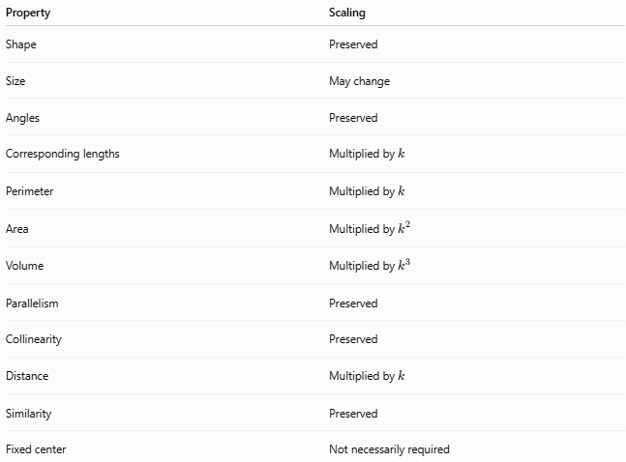
Property | Scaling
Shape | Preserved
Size | May change
Angles | Preserved
Corresponding lengths | Multiplied by $k$
Perimeter | Multiplied by $k$
Area | Multiplied by $k^{2}$
Volume | Multiplied by $k^{3}$
Parallelism | Preserved
Collinearity | Preserved
Distance | Multiplied by $k$
Similarity | Preserved
Fixed center | Not necessarily required

Types of Scaling

1. Enlargement
# Source: AI Source: Provided by: [Data Path: Persons Table -> ID Column: 1, Name_En Column: Motasem Essam] -> From: [ChatGPT] on [7/25/2026]
An enlargement occurs when:
$$\boxed{k>1}$$
The image is larger than the original.
Example:
$$L=4, k=2 \\ L^{'}=2\left(4\right)=8$$
Therefore, a length of $4$becomes $8$.

2. Reduction
# Source: AI Source: Provided by: [Data Path: Persons Table -> ID Column: 1, Name_En Column: Motasem Essam] -> From: [ChatGPT] on [7/25/2026]
A reduction occurs when:
$$\boxed{0<k<1}$$
The image is smaller than the original.
Example:
$$L=10, k=\frac{1}{2} \\ L^{'}=\frac{1}{2}\left(10\right)=5$$

3. Identity Scaling
# Source: AI Source: Provided by: [Data Path: Persons Table -> ID Column: 1, Name_En Column: Motasem Essam] -> From: [ChatGPT] on [7/25/2026]
When:
$$\boxed{k=1}$$
the figure remains unchanged.
$$L^{'}=L$$

4. Negative Scaling
# Source: AI Source: Provided by: [Data Path: Persons Table -> ID Column: 1, Name_En Column: Motasem Essam] -> From: [ChatGPT] on [7/25/2026]
If negative scale factors are permitted:
$$\boxed{k<0}$$
the image lies on the opposite side of the center of scaling, while its size is determined by $∣k∣$.
For example:
$$k=-2$$
means that the distance from the center is doubled and the point is placed on the opposite side.

Scaling About the Origin
# Source: AI Source: Provided by: [Data Path: Persons Table -> ID Column: 1, Name_En Column: Motasem Essam] -> From: [ChatGPT] on [7/25/2026]
For a point:
$$P\left(x , y\right)$$
scaling about the origin with scale factor $k$gives:
$$\boxed{P^{'}\left(k , xky\right)}$$
Therefore:
$$\boxed{\left(x , y\right)→\left(k , xky\right)}$$
Example
Let:
$$A\left(2 , 3\right)$$
and:
$$k=2$$
Then:
$$A^{'}\left(2 , ⋅22⋅3\right) \\ \boxed{A^{'}\left(4 , 6\right)}$$

Scaling About a Center Other Than the Origin
# Source: AI Source: Provided by: [Data Path: Persons Table -> ID Column: 1, Name_En Column: Motasem Essam] -> From: [ChatGPT] on [7/25/2026]
Suppose the center of scaling is:
$$C\left(h , k_{0}\right)$$
and the scale factor is $s$.
Then:
$$\boxed{x^{'}=h+s\left(x-h\right)} \\ \boxed{y^{'}=k_{0}+s\left(y-k_{0}\right)}$$
The point is scaled relative to the chosen center.

Scaling of Geometric Measurements
# Source: AI Source: Provided by: [Data Path: Persons Table -> ID Column: 1, Name_En Column: Motasem Essam] -> From: [ChatGPT] on [7/25/2026]
Length
$$\boxed{L^{'}=kL}$$
Perimeter
$$\boxed{P^{'}=kP}$$
Area
$$\boxed{A^{'}=k^{2}A}$$
Surface Area
$$\boxed{S^{'}=k^{2}S}$$
Volume
$$\boxed{V^{'}=k^{3}V}$$
Thus, a scale factor of $2$produces:
- lengths → $2$times
- perimeters → $2$times
- areas → $4$times
- volumes → $8$times

Scaling and Similarity
# Source: AI Source: Provided by: [Data Path: Persons Table -> ID Column: 1, Name_En Column: Motasem Essam] -> From: [ChatGPT] on [7/25/2026]
Scaling produces figures that have the same shape but potentially different sizes.
For corresponding lengths:
$$\frac{A^{'}B^{'}}{AB}=\frac{B^{'}C^{'}}{BC}=\frac{C^{'}A^{'}}{CA}=k$$
Corresponding angles remain equal:
$$∠A^{'}=∠A$$
Therefore:
$$\boxed{△ABC∼△A^{'}B^{'}C^{'}}$$
Scaling is therefore closely associated with similarity transformations.

Relation to Dilation

Scaling and Dilation
# Source: AI Source: Provided by: [Data Path: Persons Table -> ID Column: 1, Name_En Column: Motasem Essam] -> From: [ChatGPT] on [7/25/2026]
Dilation is a specific geometric transformation that enlarges or reduces a figure relative to a fixed center using a scale factor.
Therefore, in elementary and coordinate geometry, dilation is commonly treated as centered scaling.
$$\boxed{\text{Dilation}=\text{Scaling about a fixed center}}$$
For a center $O$and scale factor $k$:
$$\boxed{\vec{OP^{'}}=k\vec{OP}}$$
This means that:
- $O$, $P$, and $P^{'}$are collinear.
- The distance from $O$is multiplied by $∣k∣$.
- Corresponding angles are preserved.
- The resulting figure is similar to the original.
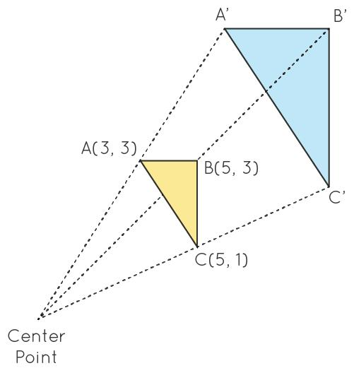
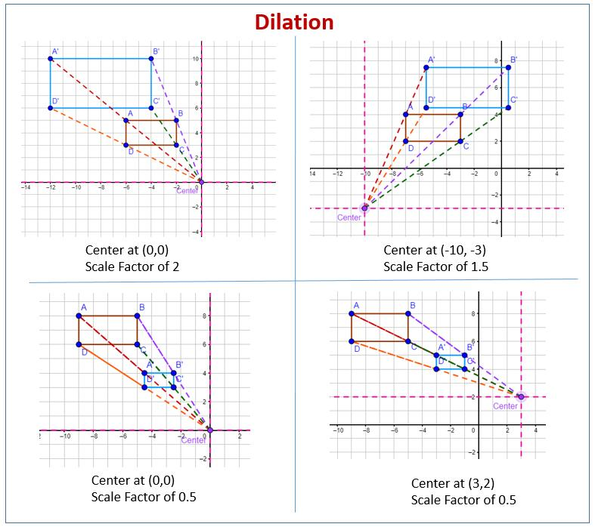
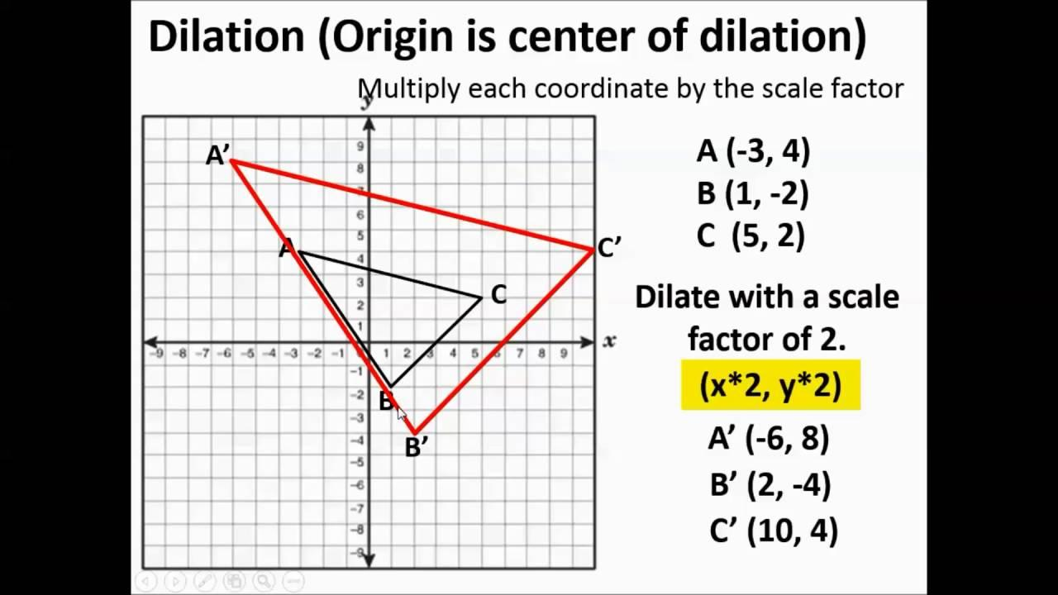

Scaling vs Dilation
# Source: AI Source: Provided by: [Data Path: Persons Table -> ID Column: 1, Name_En Column: Motasem Essam] -> From: [ChatGPT] on [7/25/2026]
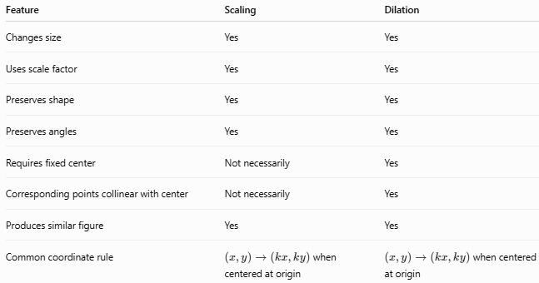
Feature | Scaling | Dilation
Changes size | Yes | Yes
Uses scale factor | Yes | Yes
Preserves shape | Yes | Yes
Preserves angles | Yes | Yes
Requires fixed center | Not necessarily | Yes
Corresponding points collinear with center | Not necessarily | Yes
Produces similar figure | Yes | Yes
Common coordinate rule | $\left(x , y\right)→\left(k , xky\right)$when centered at origin | $\left(x , y\right)→\left(k , xky\right)$when centered at origin
Important Terminology Note
The terms scaling and dilation are sometimes used interchangeably, especially in coordinate geometry.
However, when a distinction is needed:
$$\boxed{\text{Scaling = broader concept}} \\ \boxed{\text{Dilation = centered geometric transformation}}$$
So, every dilation is a form of scaling, but not every use of the word scaling necessarily specifies a dilation center.

Dilation Scale Factor
# Source: AI Source: Provided by: [Data Path: Persons Table -> ID Column: 1, Name_En Column: Motasem Essam] -> From: [ChatGPT] on [7/25/2026]
For a dilation with center $O$:
$$\boxed{k=\frac{OP^{'}}{OP}}$$
For positive $k$:
Enlargement
$$k>1$$
Reduction
$$0<k<1$$
Identity
$$k=1$$
For negative $k$:
$$k<0$$
the image lies on the opposite side of the center.

Scaling vs Homothety
# Source: AI Source: Provided by: [Data Path: Persons Table -> ID Column: 1, Name_En Column: Motasem Essam] -> From: [ChatGPT] on [7/25/2026]
Homothety is another centered form of scaling. It emphasizes the relationship between the center, original point, and image point.
$$\boxed{H_{O,k}\left(P\right)=O+k\left(P-O\right)}$$
For a centered transformation, the relationship can therefore be represented as:
$$\boxed{\text{Scaling}}⊃\boxed{\text{Dilation}}$$
and, depending on terminology:
$$\boxed{\text{Dilation}≈\text{Homothety}}$$
The exact use of dilation and homothety varies between mathematical contexts.
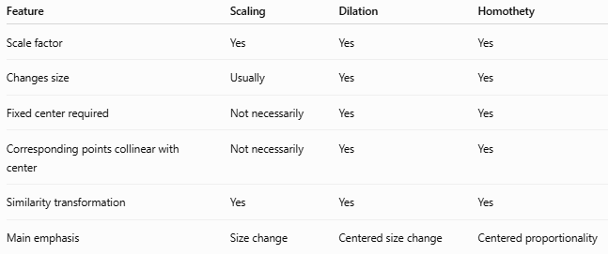
Feature | Scaling | Dilation | Homothety
Scale factor | Yes | Yes | Yes
Changes size | Usually | Yes | Yes
Fixed center required | Not necessarily | Yes | Yes
Corresponding points collinear with center | Not necessarily | Yes | Yes
Similarity transformation | Yes | Yes | Yes
Main emphasis | Size change | Centered size change | Centered proportionality

Scaling vs Isometry
# Source: AI Source: Provided by: [Data Path: Persons Table -> ID Column: 1, Name_En Column: Motasem Essam] -> From: [ChatGPT] on [7/25/2026]
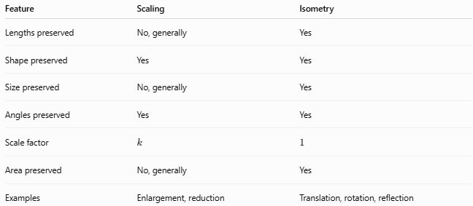
Feature | Scaling | Isometry
Lengths preserved | No, generally | Yes
Shape preserved | Yes | Yes
Size preserved | No, generally | Yes
Angles preserved | Yes | Yes
Scale factor | $$k$$ | $$1$$
Area preserved | No, generally | Yes
Examples | Enlargement, reduction | Translation, rotation, reflection
When:
$$\boxed{k=1}$$
scaling becomes an identity transformation and therefore an isometry.

Example: Scaling and Dilation of a Triangle
# Source: AI Source: Provided by: [Data Path: Persons Table -> ID Column: 1, Name_En Column: Motasem Essam] -> From: [ChatGPT] on [7/25/2026]
Consider:
$$A\left(1 , 1\right), B\left(3 , 1\right), C\left(1 , 2\right)$$
Dilate the triangle about the origin with:
$$k=2$$
Using:
$$\left(x , y\right)→\left(2 , x2y\right)$$
we obtain:
$$A^{'}\left(2 , 2\right) \\ B^{'}\left(6 , 2\right) \\ C^{'}\left(2 , 4\right)$$
Every distance from the origin has been multiplied by $2$, and every side length has also been multiplied by $2$.
The area becomes:
$$A^{'}=2^{2}A=4A$$
Thus, the image is similar to the original but has four times its area.

Classification
# Source: AI Source: Provided by: [Data Path: Persons Table -> ID Column: 1, Name_En Column: Motasem Essam] -> From: [ChatGPT] on [7/25/2026]
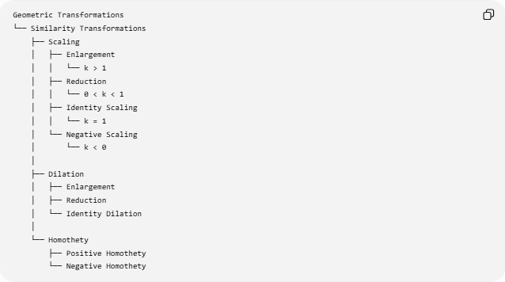
Geometric Transformations
└── Similarity Transformations
├── Scaling
│ ├── Enlargement
│ │ └── k > 1
│ ├── Reduction
│ │ └── 0 < k < 1
│ ├── Identity Scaling
│ │ └── k = 1
│ └── Negative Scaling
│ └── k < 0
│
├── Dilation
│ ├── Enlargement
│ ├── Reduction
│ └── Identity Dilation
│
└── Homothety
├── Positive Homothety
└── Negative Homothety
Taxonomy note: The tree above is conceptual rather than a universally standardized hierarchy. In many geometry curricula, dilation is itself the standard term for centered scaling, while homothety is the more specialized term for a centered similarity transformation.

Key Formulas
# Source: AI Source: Provided by: [Data Path: Persons Table -> ID Column: 1, Name_En Column: Motasem Essam] -> From: [ChatGPT] on [7/25/2026]
General Scaling
$$\boxed{d^{'}=kd}$$
Perimeter
$$\boxed{P^{'}=kP}$$
Area
$$\boxed{A^{'}=k^{2}A}$$
Volume
$$\boxed{V^{'}=k^{3}V}$$
Scaling About the Origin
$$\boxed{\left(x , y\right)→\left(k , xky\right)}$$
Dilation About a Center $O$
$$\boxed{\vec{OP^{'}}=k\vec{OP}}$$
Dilation About $\left(h , k_{0}\right)$
$$\boxed{x^{'}=h+s\left(x-h\right)} \\ \boxed{y^{'}=k_{0}+s\left(y-k_{0}\right)}$$

Classification Summary
# Source: AI Source: Provided by: [Data Path: Persons Table -> ID Column: 1, Name_En Column: Motasem Essam] -> From: [ChatGPT] on [7/25/2026]
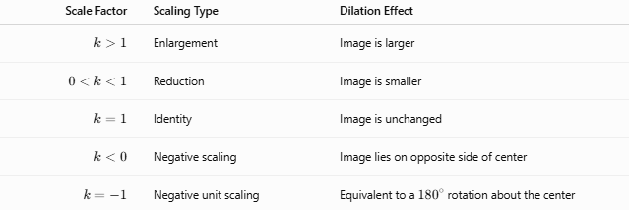
Scale Factor | Scaling Type | Dilation Effect
$$k>1$$ | Enlargement | Image is larger
$$0<k<1$$ | Reduction | Image is smaller
$$k=1$$ | Identity | Image is unchanged
$$k<0$$ | Negative scaling | Image lies on opposite side of center
$$k=-1$$ | Negative unit scaling | Equivalent to a ${180}^{∘}$rotation about the center

Key Points
# Source: AI Source: Provided by: [Data Path: Persons Table -> ID Column: 1, Name_En Column: Motasem Essam] -> From: [ChatGPT] on [7/25/2026]
- Scaling changes the size of a figure by a common scale factor.
- Scaling preserves the figure's shape and proportions.
- Dilation is a centered form of scaling.
- A dilation has a specified center of dilation.
- Corresponding points of a dilation lie on the same line through the center.
- Both scaling and dilation are associated with similarity transformations.
- Lengths scale by $k$.
- Areas scale by $k^{2}$.
- Volumes scale by $k^{3}$.
- Homothety is closely related to dilation and centered scaling.
- In many school-geometry contexts, dilation and centered scaling are essentially the same transformation.
- The main distinction is that scaling can be used as a broader concept, whereas dilation explicitly specifies a center.

Conclusion
# Source: AI Source: Provided by: [Data Path: Persons Table -> ID Column: 1, Name_En Column: Motasem Essam] -> From: [ChatGPT] on [7/25/2026]
Scaling is the general process of changing the size of a geometric figure by a common scale factor. Dilation is the standard geometric transformation that performs such scaling relative to a fixed center. Therefore, the most useful relationship is:
$$\boxed{\text{Dilation is centered scaling}}$$
with:
$$\boxed{\text{Scaling}→\text{Similarity}}$$
and, when a center is specified:
$$\boxed{\text{Scaling about a center}→\text{Dilation}}$$

